2048

version 3.0





1. Introduction

Processing is a tool for learning to code through graphic design. It is used by students, artists, researchers and the curious to quickly learn or create visuals. For example, the YouTube channel [Coding Train](https://www.youtube.com/channel/UCvjgXvBlbQiydffZU7m1_aw), which does algorithm discovery, often uses Processing in its videos. In one of his videos, he creates a [Star field](https://www.youtube.com/watch?v=17WoOqgXsRM) (displaying stars)!

Today, throughout the subject, you will be confronted with new programming concepts. In doing so, feel free to have fun on an exercise and have fun with it!



Logo de Processing

1. Consignes

* You can create a Github repository called: cc_2048.
* Don’t forget to push as things progress.
* If you have any questions, be sure to ask your neighbor to the right for help. Then left. Finally ask a Cobra (those don't bite) if you're still stuck.
* You can and you should use internet to find some answers or to get information.
* Feel free to do bonuses and add features when your project is complete and validated.

1. Processing installation

If processing is not installed on your computer, you will need to download it from [this site](https://processing.org/download/) and then install it.

This is what the processing interface looks like, and how it is used:

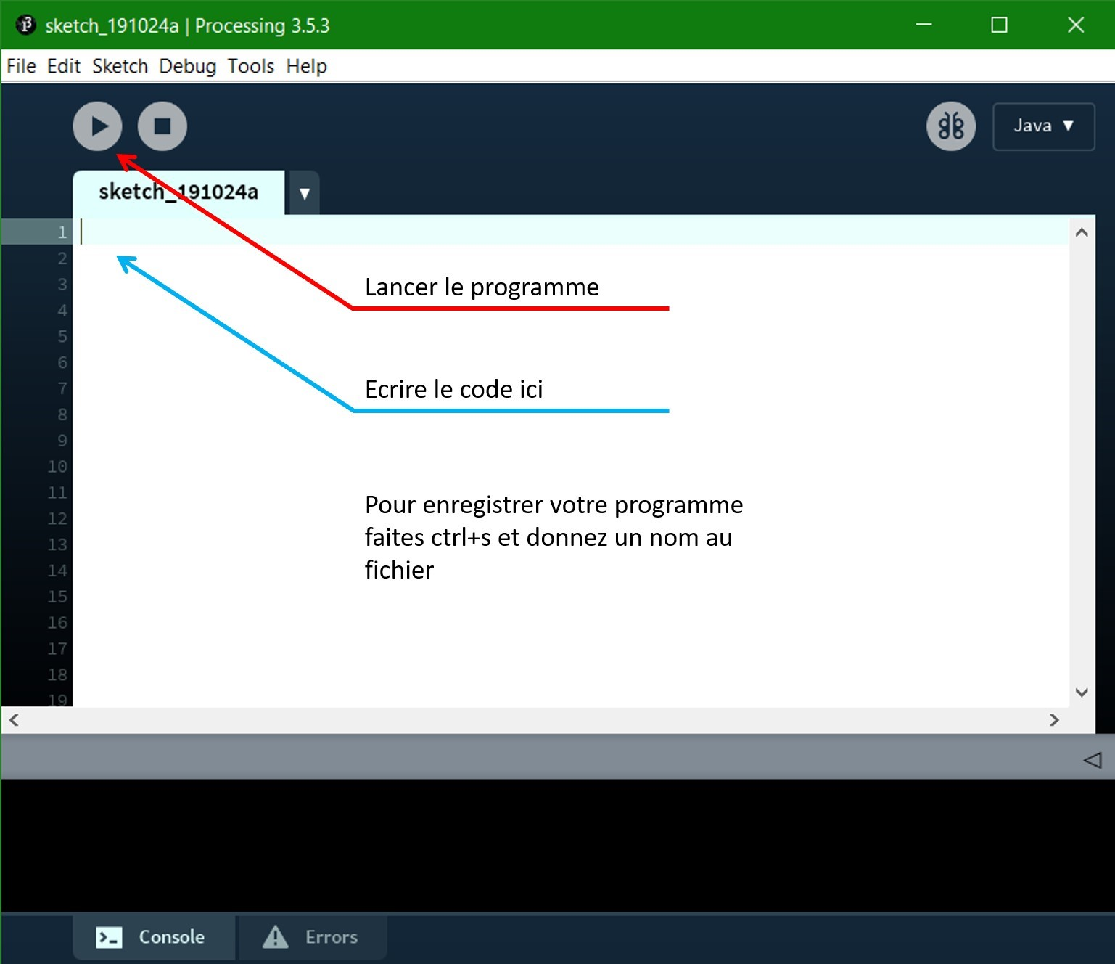

To save your code make Ctrl + S and give a name to your file

Write your code here

Launch the program

The processing interface

1. The game

A mobile game development startup led by Markus Sugarberg has been hacked and his famous game, the satisfying and addicting 2048, has been smashed by hackers! The company needs the talents of young Cerisia to fix it within two hours !

The object of the game 2048 is to merge numbers of the same value until reaching the number 2048. Here is a site that Markus Sugarberg, gives to Cerisia to familiarize himself with the game: [Play2048](https://play2048.co/)

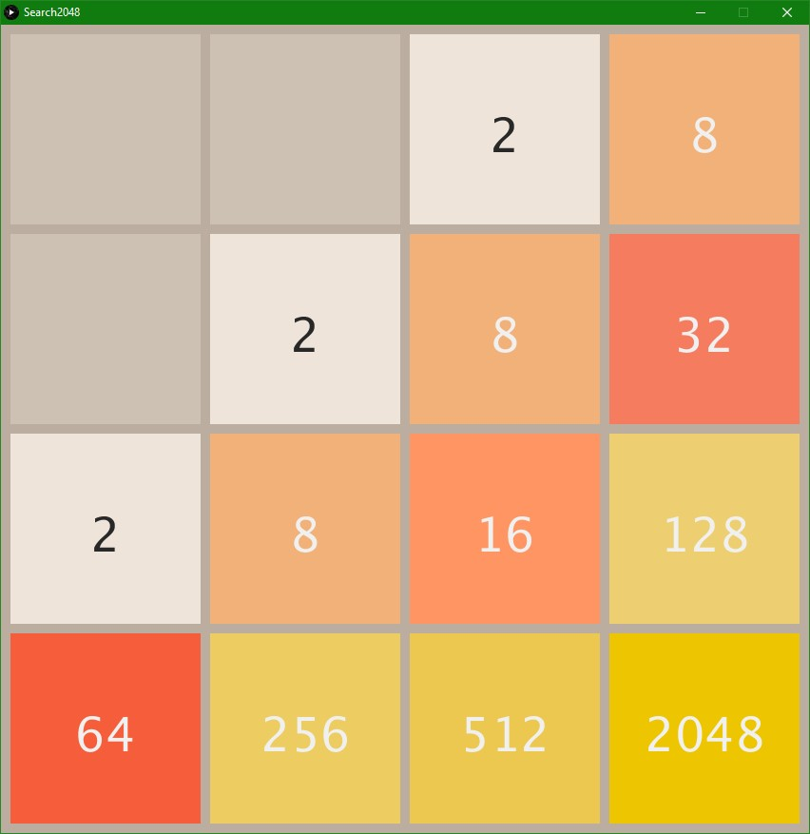

Example screen you should have

1. The code

For the mission, the head of the company gives a subject in a separate folder of the Processing files: "filename.pde" to the young developer.

With Processing installed, double-click on the files to open them. Once opened, an incomplete project code appears. Cerisia will now be able to navigate through the different tabs of the project, each corresponding to a file:



Example of tabs on Processing

You must take the time to read the code well and try to understand what it does.

* 1. The numbers have been reset!

One of the hackers broke the numbers displayed on the boxes! The values in the boxes are all 0 instead of 2 or 4. The "Tile" file must have a problem. Cerisia decides to go for a walk and try to sort this out! She learns about the functioning of [variables](https://processing.org/examples/variables.html). Mr. Sugarberg gives him a little hint: “The answer is found in the zeros”.

* 1. The boxes have lost their color!

The hackers deleted a whole part of the "Tile" file. The setColour function is empty. The function in this file and make the variable [color](https://processing.org/reference/color_.html) represents a different color depending on its [valu](https://openclassrooms.com/fr/courses/6173501-debutez-la-programmation-avec-java/6313896-utilisez-les-variables-en-programmation)e. You must add the typical colors of the game i.e., yellow, orange, and brown.

For this step, there are several ways to succeed in the exercise, the young woman is researching the internet to find the solution.

* 1. The Boxes no longer move!

Now that the game board looks like the expected result. The movement of the boxes must be repaired. For now, the player cannot even move them! For that, you must use the default Processing function: keyPressed. Go to the "Search2048" file and locate the keyPressed function.

You will also use the variable p, this variable is a bit special, because it contains functions. Find out how to use it and make this game playable!

* 1. Bugs ? But where ?

Cerisia tests her program in doubt, a bug happened so quickly. We must find the bug and fix it! If there is a bug of course.

1. Conclusion

Cerisia has succeeded in its mission! Mr. Sugarberg is extremely happy and proud. His start-up is once again on the road to success with his famous new game. Here are some bonus ideas:

Here are some bonus ideas:

* Players started to get bored having to start over around 2048 points. For this extra mission, give them longer games by increasing the number of boxes in the game screen!
* Add a time to challenge players and test their speed!
* Players don't know their score and want to know how far they can get. Display the player's score after each number merge.
* At the end of each game, the game is restarted directly, and the players do not know if it is a bug or if the game is over. Add a screen with a message to mark the end of the game.
* At the end of each game, the player no longer remembers the score he had achieved. Save the player's best score and display it on the screen.
* Players do not remember their scores and we have even seen them written on a sheet with their name.
* Add a board with usernames and their scores.